

**Faculty of engineering - Shoubra**

**Benha University**

**Research Article**

in fulfillment of the requirements of

|  |  |
| --- | --- |
| **Department** | **Engineering Mathematics and Physics** |
| **Division** | **-----------** |
| **Academic Year** | **2019-2020 Preparatory** |
| **Course name** | **Computer** |
| **Course code** | **ECE001** |

**Title: -**

**Internet of Things**

By:

|  |  |  |  |
| --- | --- | --- | --- |
|  | Name | Edu mail | B.N |
| 1 | خالد محمد أحمد عبد الله | [Khaled195348@feng.bu.edu.eg](mailto:Khaled195348@feng.bu.edu.eg) | 318 |

**Approved by:**

|  |  |
| --- | --- |
| Examiners committee | Signature |
| Dr.Ahmed Bayoumi |  |
| Dr.Shady Elmashad |  |
| Dr. Abdelhamid Attaby |  |
|  |  |
|  |  |

**Research objectives**

* to discuss the basics and benefits of IOT
* to assess the application of IOT in the various fields of human life
* to explain more about the techniques of IOT
* to know more about the revolution of using internet and technology recently
* To find answers about the problems facing us when working on this field.

**Abstract**

We are witnessing the dawn of a new era of the Internet of Things (IOT; also known as the Internet of Objects). Generally, speaking IOT refers to the networked interconnection of everyday objects, which are often equipped with ubiquitous intelligence. IOT will increase the ubiquity of the Internet by integrating every object for interaction via embedded systems, which leads to a highly distributed network of devices communicating with human beings as well as other devices. There are many applications of IOT in our daily lives, which will be discussed in that research. Besides, I want to talk and discuss more about the obstacles facing the scientists in that field.

**Table of contents**

Divide your research into sections or subjects, mention each section first page at this table

|  |  |
| --- | --- |
| **Subject / section** | **Page** |
| **Introduction** | **3** |
| **Literature Review** | **5** |
| **IOT Applications** | **7** |
| **Results and discussion** | **10** |
| **Conclusions** | **12** |
| **References** | **13** |

**List of Figures (If any)**

Figure 1:2019 emerging technologies rader for IOT projects 5

Figure 2how an IOT-enabled care device works 7

Figure 3 IOT applications in industrial automation 9

Figure 4- Conceptual representation of an urban IOT network based on the web service approach. 11

**List of Tables (If any)**

|  |  |  |
| --- | --- | --- |
| **Table I.D** | **Description** | **Page** |
| **1** | **Services Specification for the Padova Smart City Project** | **10** |

**Introduction**

THE Internet of Things (IOT) is a recent communication paradigm that envisions a near future, in which the objects of everyday life will be equipped with microcontrollers, transceivers for digital communication, and suitable protocol stacks that will make them able to communicate with one another and with the users, becoming an integral part of the Internet. The IOT concept aims at making the Internet even more immersive and pervasive. Furthermore, by enabling easy access and interaction with a wide variety of devices such as, for instance, home appliances, surveillance cameras, monitoring sensors, actuators, displays, vehicles, and so on, the IOT will foster the development of several applications that make use of the

Potentially enormous amount and variety of data generated by such objects to provide new services to citizens, companies, and public administrations. This paradigm indeed finds application in many different domains, such as home automation, industrial automation, medical aids, mobile healthcare, elderly assistance, intelligent energy management and smart grids, automotive, traffic management, and many others.

However, such a heterogeneous field of application makes the identification of solutions capable of satisfying the requirements of all possible application scenarios a formidable challenge. This difficulty has led to the proliferation of different and, sometimes, incompatible proposals for the practical realization of IOT systems. Therefore, from a system perspective, the realization of an IOT network, together with the required backend network services and devices, still lacks an established best practice because of its novelty and complexity. In addition to the technical difficulties, the adoption of the IOT paradigm is also hindered by the lack of a clear and widely

Accepted business model that can attract investments to promote the deployment of these technologies.

"It's about networks, it's about devices, and it's about data," Caroline Gorski, the head of IOT at Digital Catapult explains. IOT allows devices on closed private internet connections to communicate with others and "the Internet of Things brings those networks together. It allows devices to communicate not only within close silos but also across different networking types and creates a much more connected world

**Literature Review**

An argument has been raised that only because something can be connected to the internet does not mean it should be, but each device collects data for a specific purpose that may be useful to a buyer and affect the wider economy.

Within industrial applications, sensors on product lines can increase efficiency and cut down on waste. One-study estimates 35 percent of US manufacturers are using data from smart sensors within their set-ups already. US firm Concrete Sensors has created a device that can be inserted into concrete to provide data on the material's condition, for instance**.**

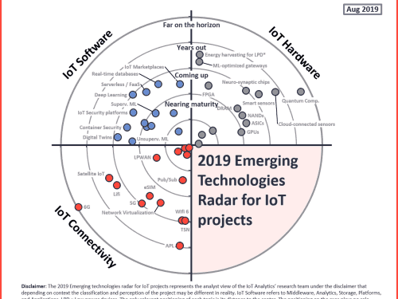

Figure 1:2019 emerging technologies radar for IOT projects

**There are some applications:**

1. IOT Applications – Wearables

Wearable technology is a hallmark of IOT applications and probably is one of the earliest industries to have deployed the IOT at its service. We happen to see Fit Bits, heart rate monitors, and smartwatches everywhere these days. One of the lesser-known wearables includes the Guardian glucose-monitoring device. The device is developed to aid people suffering from diabetes. It detects glucose levels in the body, using a tiny

Electrode called glucose sensor placed under the skin and relays the information via Radio Frequency to a monitoring device.

**2. IOT Applications – Smart Home Applications**

When we talk about IOT Applications, Smart Homes are probably the first thing that we think of. The best example I can think of here is Jarvis, the AI home automation employed by Mark Zuckerberg. There is also Allen Pan’s Home Automation System where functions in the house are actuated by use of a string of musical notes. The following video could give you a better idea.

**3. IOT Applications – Health Care**

IOT applications can turn reactive medical-based systems into proactive wellness-based systems. The resources that current medical research uses, lack critical real-world information. It mostly uses leftover data, controlled environments, and volunteers for medical examination. IOT opens ways to a sea of valuable data through analysis, real-time field data, and testing. The Internet of Things also improves the current devices in power, precision, and availability. IOT focuses on creating systems rather than just equipment. Moreover, that is how an IOT-enabled care device works.

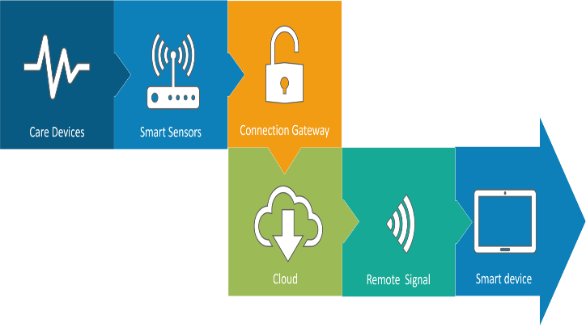

Figure 2how an IOT-enabled care device works

**4. IOT Applications – Smart Cities**

By now, I assume, most of you must have heard about the term Smart City. The hypothesis of the optimized traffic system I mentioned earlier is one of the many aspects that constitute a smart city.

The thing about the smart city concept is that it is very specific to a city. The problems faced in Mumbai are very different from those in Delhi. The problems in Hong Kong are different from New York. Even global issues, like finite clean drinking water, deteriorating air quality, and increasing urban density, occur in different intensities across cities. Hence, they affect each city differently.

The Government and engineers can use IOT to analyze the often-complex factors of town planning specific to each city. The use of IOT applications can aid in areas like water management, waste control, and emergencies.

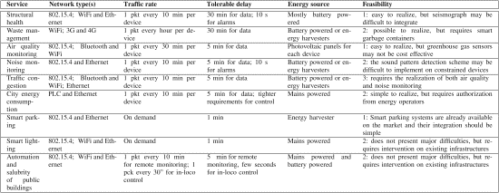

TABLE I Services Specification for the Padova Smart City Project

**5. IOT Applications – Industrial Automation**

This is one of the fields where both faster developments, as well as the quality of products, are the critical factors for a higher Return on Investment. With IOT Applications, one could even re-engineer products and their packaging to deliver

Better performance in both cost and customer experience. IOT here can prove to be game changing with solutions for all the following domains in its arsenal.

* Factory Digitalization
* Product flow Monitoring
* Inventory Management
* Safety and Security
* Quality Control
* Packaging optimization
* Logistics and Supply Chain Optimization

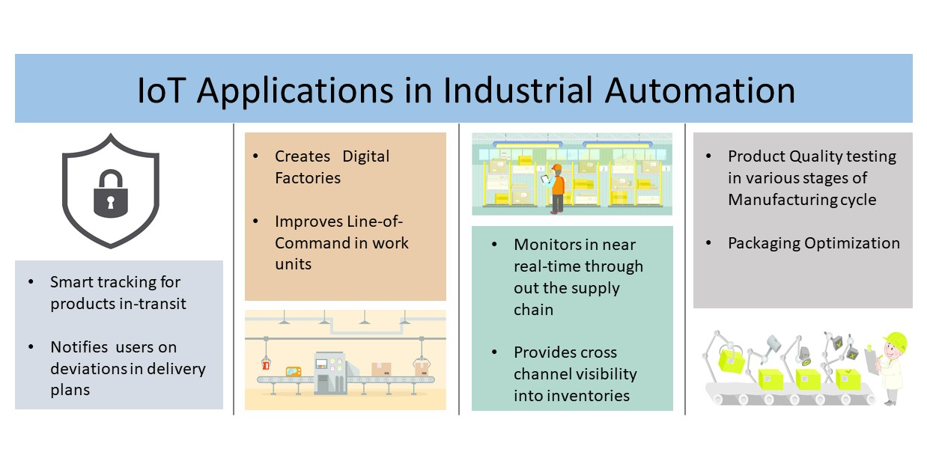

Figure 3 IOT applications in industrial automation

**Results and discussion**

Humans seek to make everything in the service of the IOT technology. However, there are some points to be clear about the programming used in IOT and its types. Although in the IOT domain many different standards are still struggling to be the

Reference 1 and the most adopted, in this section we focus specifically on The Internet Engineering Task Force (IETF) standards because they are open and royalty-free, are based on Internet best practices, and can count on a wide community.

The IETF standards for IOT embrace a web service architecture for IOT services, which has been widely documented in the literature as a very promising and flexible approach. Web services permit to realize a flexible and interoperable system that can be extended to IOT nodes, through the adoption of the web-based paradigm known as Representational State Transfer (ReST) [18]. IOT services designed following the ReST paradigm exhibit very strong similarity with traditional web services, thus greatly facilitating the adoption and use of IOT by both end-users and service developers, which will be able to easily reuse much of the knowledge gained from traditional web technologies in the development of services for networks containing smart objects. The web service approach is also promoted by international standardization bodies such as IETF, ETSI, and W3C, among others, as well as European research projects on the IOT such as SENSEI,5 IOT-A,6 and SmartSantander.

Apparently, there are a lot of jobs will disappear from the world like, Cashiers, Librarians, Postal Couriers, Bank Tellers, Textile Workers, The Print Industry, Sports Referees and Umpires.

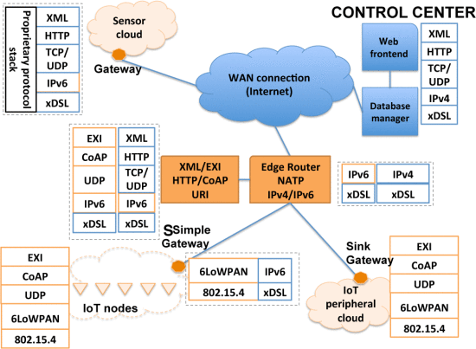>

Figure 4- Conceptual representation of an urban IOT network based on the web service approach.

**Conclusions**

Connected machines and objects in factories offer the potential for a 'fourth industrial revolution’. It is expected that by 2025 there will be more than to 21 billion IOT device, which is a great matter. Moreover, the programming field would be the most beneficial and promising field of all industries.

We all have to be assiduous and learn to share in the future of the world. We already have turned the planet into a paradise but we still lack some knowledge and we still have a lot to do.

**References**

**1-Balaji, M. S., & Roy, S. K. (2017). Value co-creation with the Internet of things technology in the retail industry. Journal of Marketing Management, 33(1-2), 7-31. https://doi.org/10.1080/0267257X.2016.1217914, https://doi.org/10.1080/0267257X.2016.1217914**

**10.1080/0267257X.2016.121791410.1080/0267257X.2016.1217914 in** [**https://research-repository.uwa.edu.au/en/publications/value-co-creation-with-internet-of-things-technology-in-the-retai**](https://research-repository.uwa.edu.au/en/publications/value-co-creation-with-internet-of-things-technology-in-the-retai)**.**

**2-**[**https://ieeexplore.ieee.org/document/6740844/figures#figures**](https://ieeexplore.ieee.org/document/6740844/figures#figures)

**3-L. Atzori, A. Iera, and G. Morabito, "The internet of things: A survey", Comput. Netw., vol. 54, no. 15, pp. 2787-2805, 2010.**

**4-. P. Bellavista, G. Cardone, A. Corradi and L. Foschini, "Convergence of MANET and WSN in IOT urban scenarios", IEEE Sens. J., vol. 13, no. 10, pp. 3558-3567, Oct. 2013.**

**5-** **A. Laya, V. I. Bratu and J. Markendahl, "Who is investing in machine-to-machine communications?", Proc. 24th Eur. Reg. ITS Conf., pp. 20-23, Oct. 2013.**

**6-** [**https://www.wired.co.uk/article/internet-of-things-what-is-explained-IOT**](https://www.wired.co.uk/article/internet-of-things-what-is-explained-iot)

**7-** [**https://www.edureka.co/blog/IOT-applications/**](https://www.edureka.co/blog/IOT-applications/)

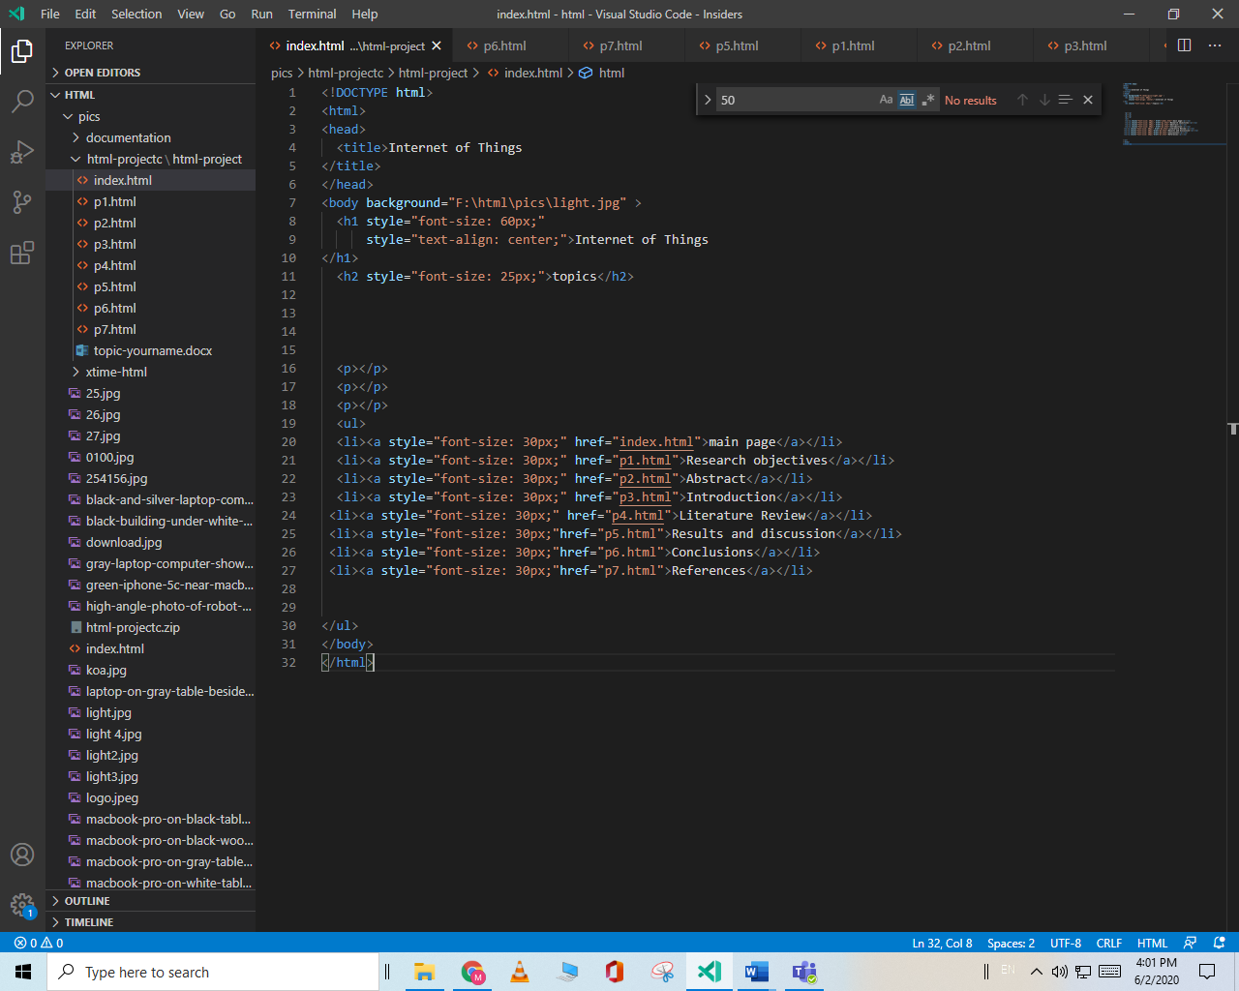

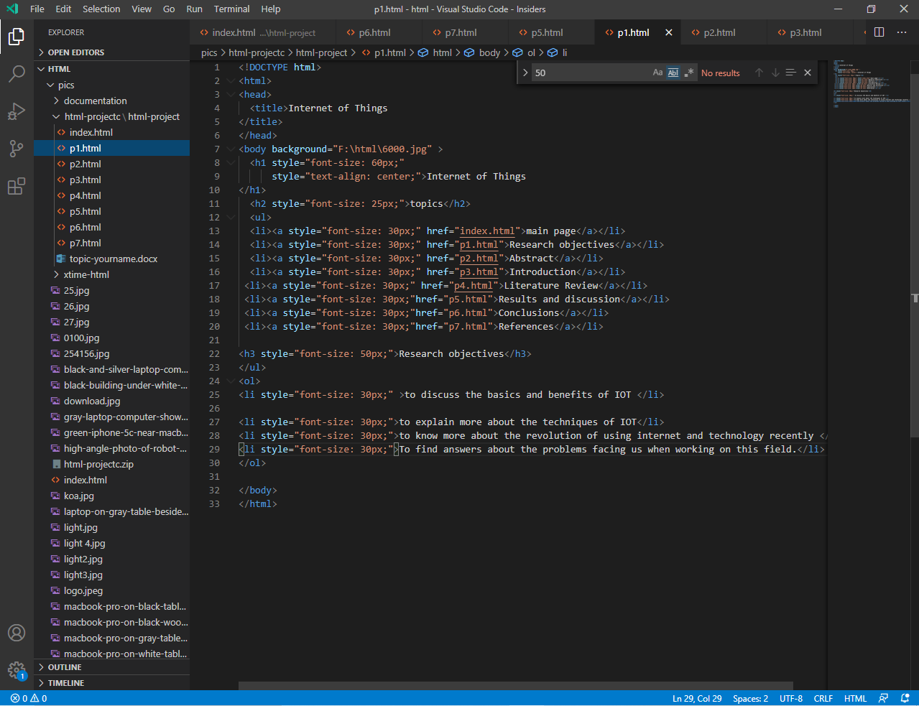

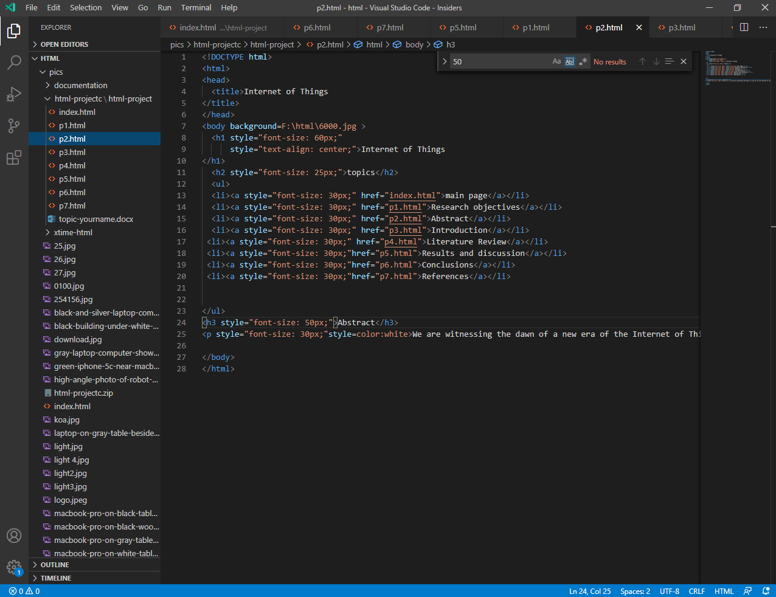

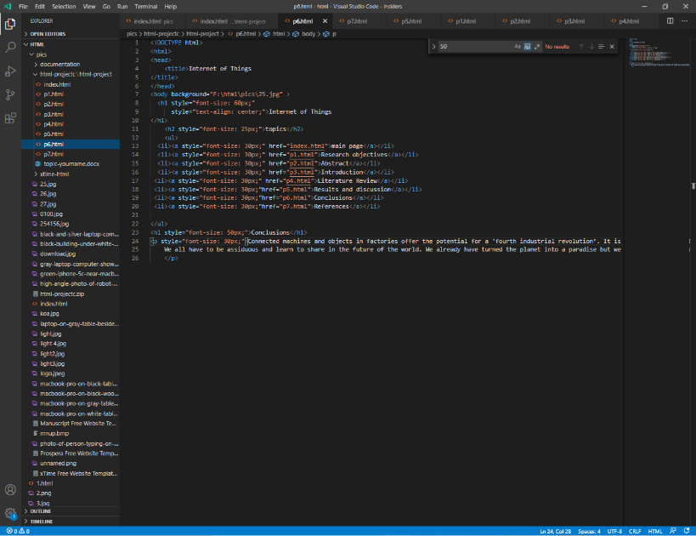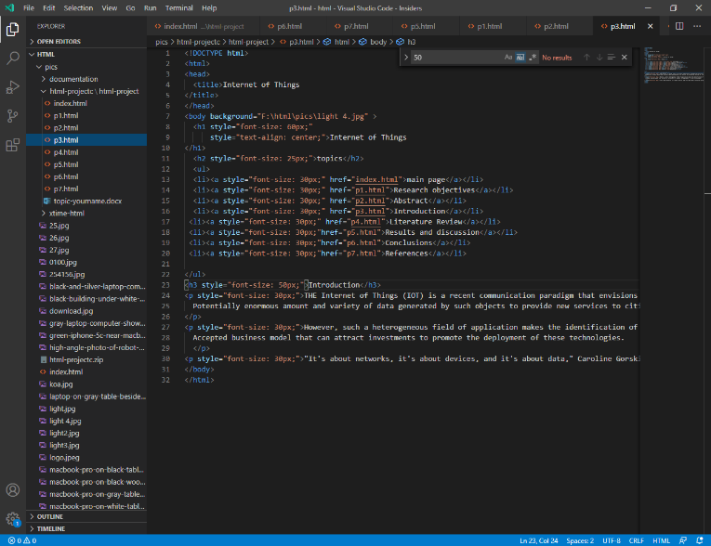

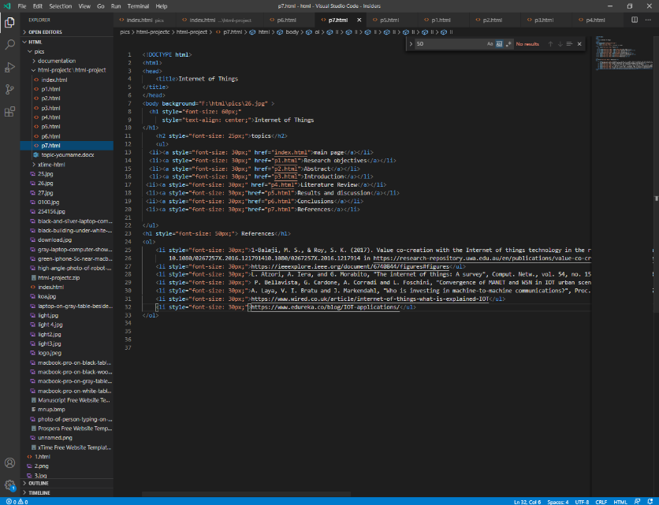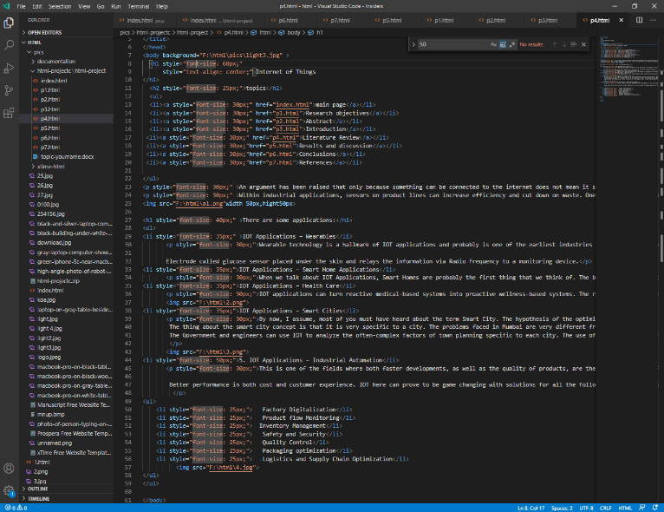

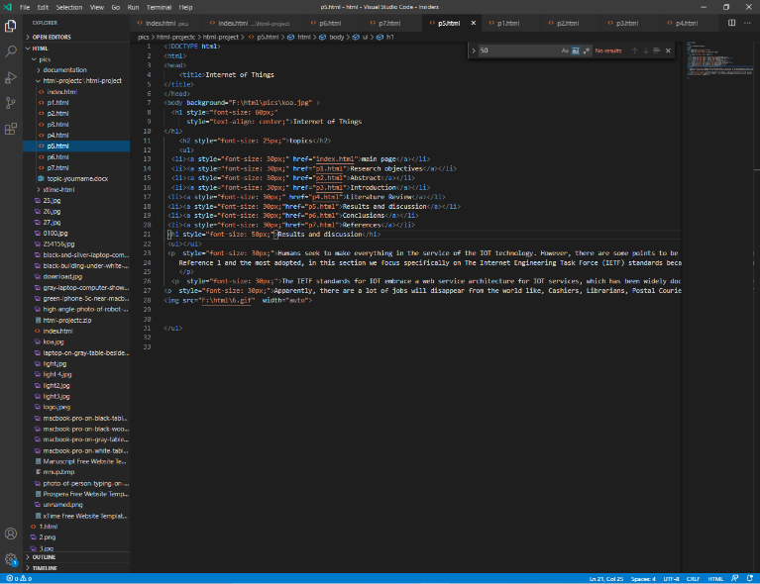

<!DOCTYPE html>

<html>

<head>

<title>Internet of Things

</title>

</head>

<body background="F:\html\pics\25.jpg" >

<h1 style="font-size: 60px;"

style="text-align: center;">Internet of Things

</h1>

<h2 style="font-size: 25px;">topics</h2>

<ul>

<li><a style="font-size: 30px;" href="index.html">main page</a></li>

<li><a style="font-size: 30px;" href="p1.html">Research objectives</a></li>

<li><a style="font-size: 30px;" href="p2.html">Abstract</a></li>

<li><a style="font-size: 30px;" href="p3.html">Introduction</a></li>

<li><a style="font-size: 30px;" href="p4.html">Literature Review</a></li>

<li><a style="font-size: 30px;"href="p5.html">Results and discussion</a></li>

<li><a style="font-size: 30px;"href="p6.html">Conclusions</a></li>

<li><a style="font-size: 30px;"href="p7.html">References</a></li>

</ul>

<h1 style="font-size: 50px;">Conclusions</h1>

<p style="font-size: 30px;">Connected machines and objects in factories offer the potential for a 'fourth industrial revolution’. It is expected that by 2025 there will be more than to 21 billion IOT device, which is a great matter. Moreover, the programming field would be the most beneficial and promising field of all industries.

We all have to be assiduous and learn to share in the future of the world. We already have turned the planet into a paradise but we still lack some knowledge and we still have a lot to do

**</p><**

**/body>**

**</html>**